**Student Name:**

**Student ID:** **Marks: /12**

# Lab: Unit 09 Manipulating Data

## Equipment and Materials

For this lab, you will need:

* A Windows computer with a minimum of 16GB RAM and 250GB free disk space, capable of nested virtualization
* Access to Oracle Version 11g or better through SQL*PLUS.

## Problem Set

Create the Grand Hill College Database with the script provided. Write SQL code to perform the following modifications to the Grand Hill College Database. Place the code in a single file and execute it without errors.

1. Add a new department
   1. Department number: 200
   2. Name: Computer Science

Add a new department

* 1. Department number: 300
  2. Name: Mathematics

1. Add a new instructor with the following information:
   1. Faculty ID: 1001
   2. Name: James Gosling
   3. Hired: Jan 1, 2022
   4. This instructor is currently available and teaches in the Computer Science department

Add another instructor with the following information:

* 1. Faculty ID: 1002
  2. Name: Mohammed Hajit
  3. Hired: Jan 1, 2024
  4. This instructor is currently available and teaches in the Computer Science department

1. Add the following courses that James Gosling and record that he has expertise to teach:
   1. Course Code: CPSC201, Introduction to Programming, 3 credits
   2. Course Code: CPSC302, OOP, 5 credits
   3. Course Code: CPSC304, Algorithrms , 5 credits
2. Add the following courses that Mohammed Hajit and record that he has expertise to teach:
   1. Course Code: CPSC201, Introduction to Programming, 3 credits
   2. Course Code: CPSC302, OOP, 5 credits
   3. Course Code: CPSC304, Alogithrms , 5 credits
   4. Course Code: CPSC402, OOP II, 5 credits
3. Run the following script to verify that the data is correct:

select surname, dept_name, date_hired, course_code  
from ghc_course natural join ghc_expertise natural join  
 ghc_faculty natural join ghc_department  
order by 1,4;;

Output should match the following:

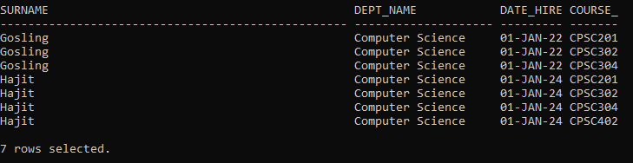

1. Change the name of CPSC302 to be ‘Object Oriented Programming’ and set the number of credits to be 6.
2. REMOVE CPSC304 and any related expertise records.
3. Run the following script to verify that the data is correct:

select course_code, course_title, faculty_id  
from ghc_course natural join ghc_expertise   
 natural join ghc_faculty  
order by 1,2;

Output should match the following:

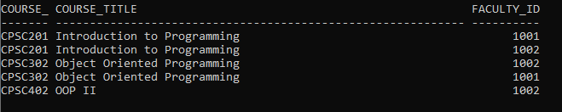

## Tips and Tricks

1. You may need to restore the Grand Hill College to its original state more than once (by running the create script again) until you get all commands in your script to work correctly.

## Instructions

1. Use the Grand Hill College database to solve these questions. Create and populate the Grand Hill College database FIRST before working on this lab. Information on how to create and populate the Grand Hill College database can be found in the course resources->database section of Brightspace.
2. Reference the physical model for Grand Hill College as provided in the course resources->database section of Brightspace.
3. Write a single script that answers all the questions in the problem set.
4. Solve all the problems INDIVIDUALLY first.
5. Arrange a time to come together as a small group to create a group submission based on the best individual solution for each question. Only ONE group submission is required.
6. Include the script as well as a spool file showing all the results.
7. Include and submit an attribution list that outlines the activities, time spent and resources associated with completing this assignment. A sample attribution list is provided:

|  |  |  |  |
| --- | --- | --- | --- |
| Activity | Date | Resources | Tim spent (hours) |
| Initial group meeting | May 10, 2 PM | Dave, Fred, Kricket, Sara | 0.25 |
| Working through lab individually | May 11, 3 PM | Dave | 1 |
| Working through lab individually | May 11, 6 pm | Fred | 1 |
| Working through lab individually | May 12, 3 pm | Sara | 0.5 |
| Working through lab individually | May 12, 2 pm | Kricket | 0.5 |
| Final meeting to review individual submissions and create group submission | May 14, 3 PM | Dave, Fred, Kricket, Sara | 1.0 |
| Total Person Hours |  |  | 4.25 hours |

## Marking Criteria

